Determining Wavelength using a Diffraction Grating

# Introduction

Light diffraction occurs due to the bending of lights as it passes over the edge of an object (University of Illinois, 2010). Thomas Young explained that this diffraction was due to the wave-like nature of light in 1801 using a double slit experiment (Las Cumbres Observatory, n.d.). As a result of this wave-like nature, light would inherit the wave property of construction and destructive interference, much like that of ocean waves (Abramowitz et al., 2015). Young identified that the constructive interference pattern of light could be modelled by the following equation (Knight, 2022, p. 990).

$$dsinθ=mλ$$

$Where:$

$$d=The distance between two slits$$

$$θ=The angle at which the light is diffracted$$

$$m=The integer value of light construction from the centre fringe$$

$$λ=The wavelength of light$$

This experiment aimed at experimentally establishing the wavelength of an unknown green light laser utilising a diffraction grating setup and the previously mentioned equation.

# Theory

When attempting to analyse light, it is easy to misconstrue its complexity for a simple wave or particle depending on how it is observed, thus leading to the perceived wave-particle duality of light (Baird, 2013). The wavelength of a given wave of light corresponds to its peak-to-peak or trough-to-trough distance. As shown in figure 1, a lights wavelength (within the visible light domain) is responsible for its perceived colour (Harper College, n.d.).

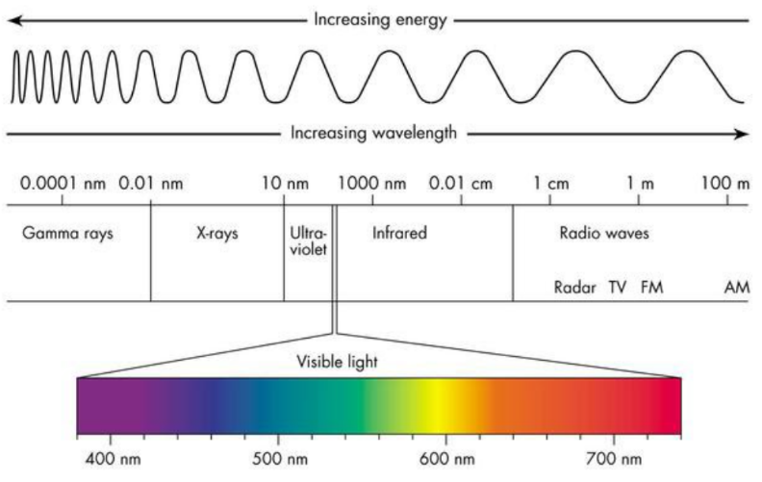Previous external experiments conducted by the Army Republic Health Centre claim that green laser light occupies a wavelength between 520 and 532 nm (APHC, n.d.). To evaluate the accuracy of the experiment, this wavelength range would prove useful as an expected result for the experiment.

Figure : Spectrum of light (Franson, n.d.).

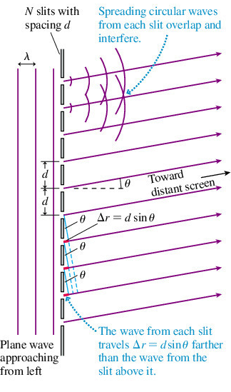Diffraction gratings interact with the wave-like properties of light by passing the light wave through a construed space which results in the wave spreading once it exits the slit. This is demonstrated in figure 2.

Simple trigonometry dictated that the angle of diffraction was equivalent to the tangent of the distance of one high intensity light fringe from the center one ($y_{m}$) divided by distance to the screen (L).

$$y_{m}=L*tanθ$$

Decreasing d or increasing the number of slits will induce more waves and result in an increase in both the intensity of the primary construction maxima, according to $I=\frac{1}{N^{2 }}$, and an increase the wave destruction occurring between each of the maxima (LibreTexts, 2022). This is clearly demonstrated in the two slit vs multiple slit demonstration in figure 3.

Figure : Diffraction grating diagram (Knight, 2022, p. 990).

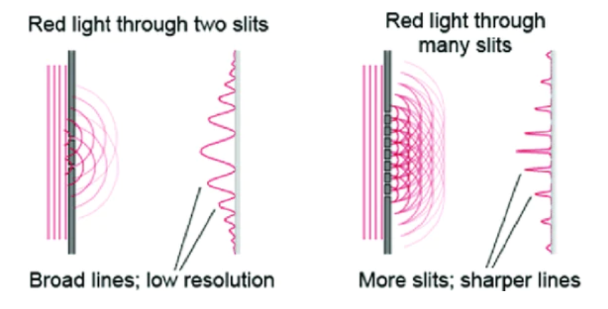

Figure : Double slit vs multiple slit diffraction grating (Science Ready, n.d.)

# Method

The experimental setup consisted of an optical rail, on which was placed the green laser, a single slit collimator, a lens and finally a labeled turntable which held the diffraction grating (figure 4). The light from this setup then landed on a graphing paper screen. The entire setup remained in this position with a constant:

* Collimator width.
* Parallel position between the diffraction grating and the screen.
* 14.5cm between the diffraction grating and the screen.

Figure 4: Experiment setup.

To begin the experiment, the laser was turned on and shone directly through the setup with a 100lines/mm diffraction grating. A ruler was then used to measure the distance from the central high intensity light fringe to each of the other light fringes. This same procedure was then applied to the 300 and 600 lines/mm diffraction gratings.

Two sources of uncertainty were discovered within this setup, the uncertainty in the distance between the diffraction grating and the screen, and the uncertainty in the distance from each light fringe from the central fringe. Both uncertainties arise as a result of the measuring instruments (the ruler and graphing paper) having a minimum increment value of 1mm. Therefore, the uncertainty in the values were evaluated at 0.5mm for both, half the smallest increment.

# Results and Analysis

The raw data from the experiment was recorded in table 1. From this data, the sample calculations shown in figure 5 outline how the results were transformed into a θ value which could be later used in the diffraction grating equation.

$$y_{m}=L*tanθ$$

For $y_{m}= -15.3, L= -14$

$$-15.3=-14*tanθ$$

$$θ= arctan⁡(\frac{-15.3}{-14})$$

$θ=$-0.829737684

Figure : Sample calculations for .

When treating $\frac{d}{λ}sinθ=m$ as a linear equation with $sinθ$ and m as the y and x axis respectively, it becomes clear that the gradient of this equation would equal to $\frac{d}{λ}$. This graph was constructed in figure 7 and equipped with error bars, although small, to evaluate how large of an impact the uncertainties previously mentioned propagated into the results. A sample of the propagated uncertainty for sin $θ$ was provided in figure 6, see appendix 1 for full calculations.

Figure : Sample calculations for uncertainty in sin($θ$).

$$∆θ=\sqrt{{\left(\frac{∂θ}{∂L}\right)}^{2}*∆L^{2}+{\left(\frac{∂θ}{∂y_{m}}\right)}^{2}*∆y_{m}^{2}}$$

$$θ=arctan⁡(\frac{y_{m}}{L})$$

$∆θ= \sqrt{\left(\frac{1}{L^{2}+ y_{m}^{2}}\right)*{\left(0.5*{10}^{-2}\right)}^{2}}$

For $y_{m}= -15.3, L= -14$

$∆θ=$ 0.002

≈ 0.002

Table : Raw data and values

Figure : Graph of the diffraction grating equation.

The gradients for each of the linear equations, when evaluated as $\frac{λ}{d}$, experimentally calculated the wavelength of the green laser to be 525, 518 and 522.83 nm for the 100, 300 and 600 lines/mm gratings respectively. This resulted in an average wavelength value of 521.9 ± 3.5nm.

To fully evaluate the total uncertainty of the wavelength value, the uncertainty propagation from the initially outlined L and ym values was to be calculated. The propagation of uncertainty was calculated using the University of Queensland’s five-minute physics program. The program determined the uncertainties in the gradients using the previously determined uncertainty values in sin $θ$. The largest uncertainty in the gradient belonged to the 300 line/mm equation with an uncertainty of 0.00052.

As the gradient was equivalent to $\frac{λ}{d}$, this maximum propagation of uncertainty in the gradient resulted in an uncertainty in the wavelength of 1.7nm. This sums to an average wavelength of 521.9 ± 5.2nm. This lies comfortably in the theoretical range of 520 to 532 nm proposed by the APHC.

# Conclusion

This report aimed at experimentally identifying the wavelength of an unknown green laser. This was achieved by using a diffraction grating experiment and its coexisting equations $y_{m}=L*tanθ$ and $dsinθ=mλ$. The analysed raw data concluded that the wavelength of the green laser was 521.9 ± 5.2nm, an uncertainty calculated through UQ’s five-minute physics program. This wavelength result was coherent with the scientifically accepted 520 to 532 nm range for the green laser wavelengths.

# References

Abramowitz, M., Neaves, S. H., & Davidson, M. W. (2015, November 13). Molecular expressions: Science, optics, and you: Light and color - Interference. Molecular Expressions: Images from the Microscope. <https://micro.magnet.fsu.edu/optics/lightandcolor/interference.html>

APHC. (n.d.). Visible Wavelength Handheld Laser Pointers. <https://phc.amedd.army.mil/PHC>

Baird, C. S. (2013, January 16). Is light a particle or a wave? Science Questions with Surprising Answers. <https://www.wtamu.edu/~cbaird/sq/2013/01/16/is-light-a-particle-or-a-wave/>

Franson, J. (n.d.). Electromagnetic spectrum - Principles of structural chemistry. <https://sites.google.com/a/coe.edu/principles-of-structural-chemistry/relationship-between-light-and-matter/electromagnetic-spectrum>

Harper College. (n.d.). Spectroscopy - Seeing colors. Harper College Departmental Websites. <https://dept.harpercollege.edu/chemistry/chm/100/dgodambe/thedisk/spec/5back3.htm>

Knight, R. (2022). Physics for scientists and engineers: A strategic approach : with modern physics.

Las Cumbres Observatory. (n.d.). Light as a wave. <https://lco.global/spacebook/light/light-wave/>

LibreTexts. (2022, September 25). University physics. Physics LibreTexts. <https://phys.libretexts.org/Bookshelves/University_Physics>

Science Ready. (n.d.). Diffraction of light & young's double slit experiment – HSC physics. <https://scienceready.com.au/pages/diffraction>

University of Illinois. (2010). Diffraction of light: Light bending around an object. WW2010 (the weather world 2010 project):. <https://ww2010.atmos.uiuc.edu/(Gh)/guides/mtr/opt/mch/diff.rxml>

# Appendix 1: Propagation of Uncertainty in sinθ

